PRESS RELEASE

EMBARGO: 25th July 2019
12:00 BST / 13:00 CEST

NEW DAYTONA Moto2TM 765
LIMITED EDITION

TO BE REVEALED: 23rd August 2019 – GoPro British Grand Prix

Following overwhelmingly positive customer demand, Triumph Motorcycles confirm the introduction of the ultimate edition of the legendary, multiple Supersport Championship-winning Daytona, which will be officially revealed at a special press event at the GoPro British Grand Prix at Silverstone on Friday 23rd August 2019.

- New Daytona Moto2TM 765 Limited Edition
- Highest ever power and torque from its new Moto2TM-derived 765cc
triple engine
- Highest ever specification and rider technology
- Precision-perfect, championship-winning chassis
- First ever official Moto2TM Dorna Sports.SL licenced motorcycle
- Limited run of individually numbered motorcycles, with only 765 for Europe
and Asia, and 765 for the US and Canada.

The new Daytona Moto2TM 765 Limited Edition will represent both the highest specification of the British racing legend, and a unique partnership with the FIM MotoGPTM World Championship.

Triumph will launch two versions of the eagerly-anticipated new Daytona on 23rd August, one for Europe and Asia, and one for the US and Canada. Both will feature a new Moto2TM derived 765cc triple engine inside a championship-winning sports-focused chassis, delivering the highest power and torque ever from a production 765cc, plus the highest specification of equipment ever, and a limited edition race paint scheme.

Reflecting Triumph’s position as the exclusive engine supplier to the Moto2TM class of the FIM MotoGPTM World Championship, and sharing some of the key developments from the race engine programme, both models will be revealed at a special press event on Friday 23rd August at Silverstone, where full specifications and details will be revealed. Both bikes will also be showcased in a spectacular parade lap over the race weekend, ridden by two former motorcycle world champions.

This new limited edition Daytona delivers the closest you can get to a genuine Moto2TM factory ride for the road.

With a limited run of only 765 being built of each model (Europe/Asia & US/Canada), each one individually numbered, Triumph are anticipating strong demand for this truly unique motorcycle.

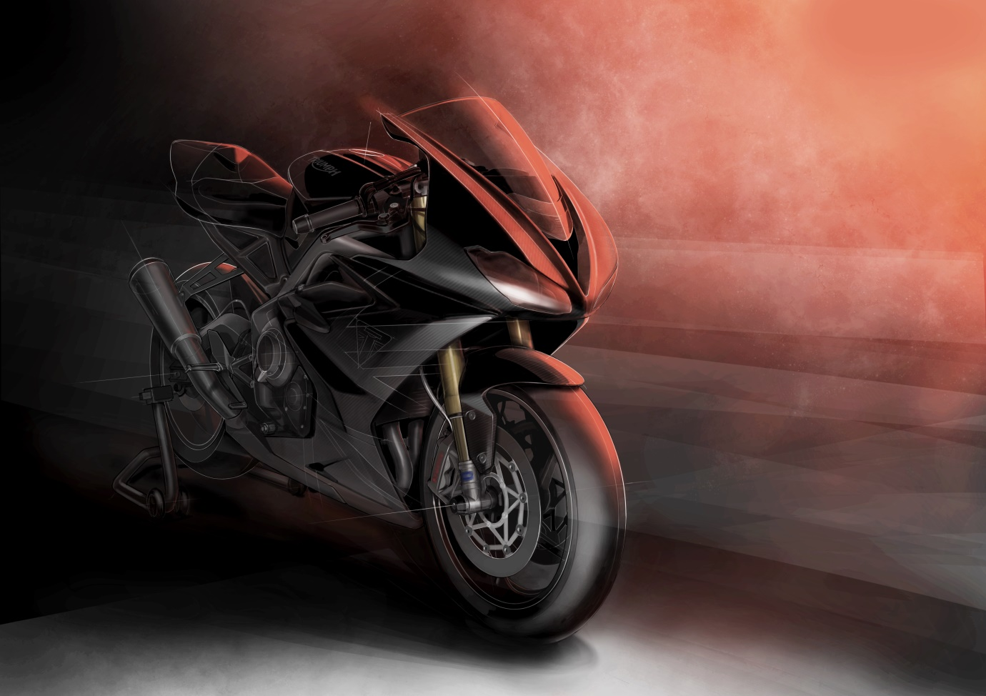

- END -

For further information contact Tom Robinson on tom.robinson@triumph.co.uk

Notes to Editors
About Triumph
- The Triumph Moto2™ 765cc race engine is a development of the class-leading Street Triple RS 765cc road motorcycle and is producing more than 140PS and the same visceral soundtrack.
- First established in 1902, Triumph Motorcycles celebrated 115 years of motorcycle manufacture in 2017. For more than three decades, Triumph Motorcycles has been based in Hinckley, Leicestershire, and has produced iconic bikes that perfectly blend authentic design, character, charisma and performance.

- Building around 65,000 bikes per year, Triumph is the largest British motorcycle manufacturer and has around 650 dealers across the world.

- This focus, innovation and engineering passion has today created a broad range of bikes suited to all motorcycle riders, including the iconic new Scrambler 1200, epic Speed Triple, the game changing all new Street Triple 765, the class defining Tiger 800, transcontinental Tiger 1200, iconic Triumph Bonneville family including the stunning Speed Twin, Bonneville Bobber, legendary Thruxton, accessible Street Twin, Street Scrambler and iconic Bonneville T120 and T100, plus an exciting and accessible A2 range of Triumph motorcycles.

- Triumph currently employs around 2,000 personnel worldwide and has subsidiary operations in the UK, North America, France, Germany, Spain, Italy, Japan, Sweden (Scandinavia), Benelux, Brazil, India and Thailand as well as a network of independent distributors. Triumph has manufacturing facilities in Hinckley, Leicestershire, and Thailand plus CKD facilities in Brazil and India.

- The Triumph Bonneville, famously named to celebrate Triumph’s 1956 land speed record on the Bonneville Salt Flats in Utah, USA, was the original British superbike and a race-winner straight out of the crate, chosen by famous motorcyclists of the past for its legendary handling, style, and character. It’s that handling, character and style, married to modern rider-focused technology that makes the new Bonneville family THE authentic modern classic choice today.

- Triumph has a glorious racing history, competing in and winning races in almost every class and field of motorcycle sporting achievement. From winning the second ever Isle of Man TT in 1908, through to 1960s road and track domination in Europe and America, right up to contemporary racing achievements with the 675cc Triumph triple powered 2014 Daytona 200 win, the 2014 Isle of Man Supersports TT, 2014 and 2015 British Supersports titles and World SuperSport racing. And now with the new generation of 765cc triple engine powering the 2019 Moto2™ championship, Triumph’s racing legend continues.

